Seaport³ Screen Shots from Logic & Critical Thinking - PHIL-C115-003

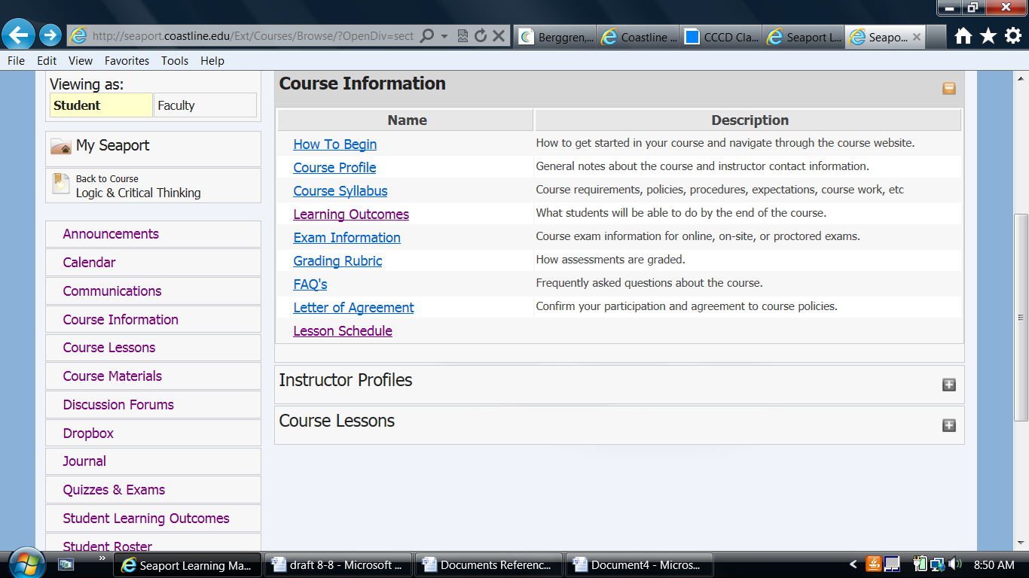

Student selects “Course Information” (above) to get to course SLOs, shown in screen below.

